**Title: Crime Analyst**

**Submitted by:**

Aysha Al Rashid

**Simplilearn Tableau Training - Data Analyst - Crime Analyst**

**Date: 3rd Feb 24**

**Introduction:**

With how fast the world is evolving, we need innovative ways to sort the data and provide rapid solutions to problems. One of the ways is crime analysis which helps law enforcement agencies understand patterns and trends in criminal activity, allowing them to allocate resources more effectively. By identifying hotspots or recurring patterns, they can deploy officers to specific areas and times where they are most needed.

1.**Geo map** was used to identify hotspot places for crimes throughout the year.

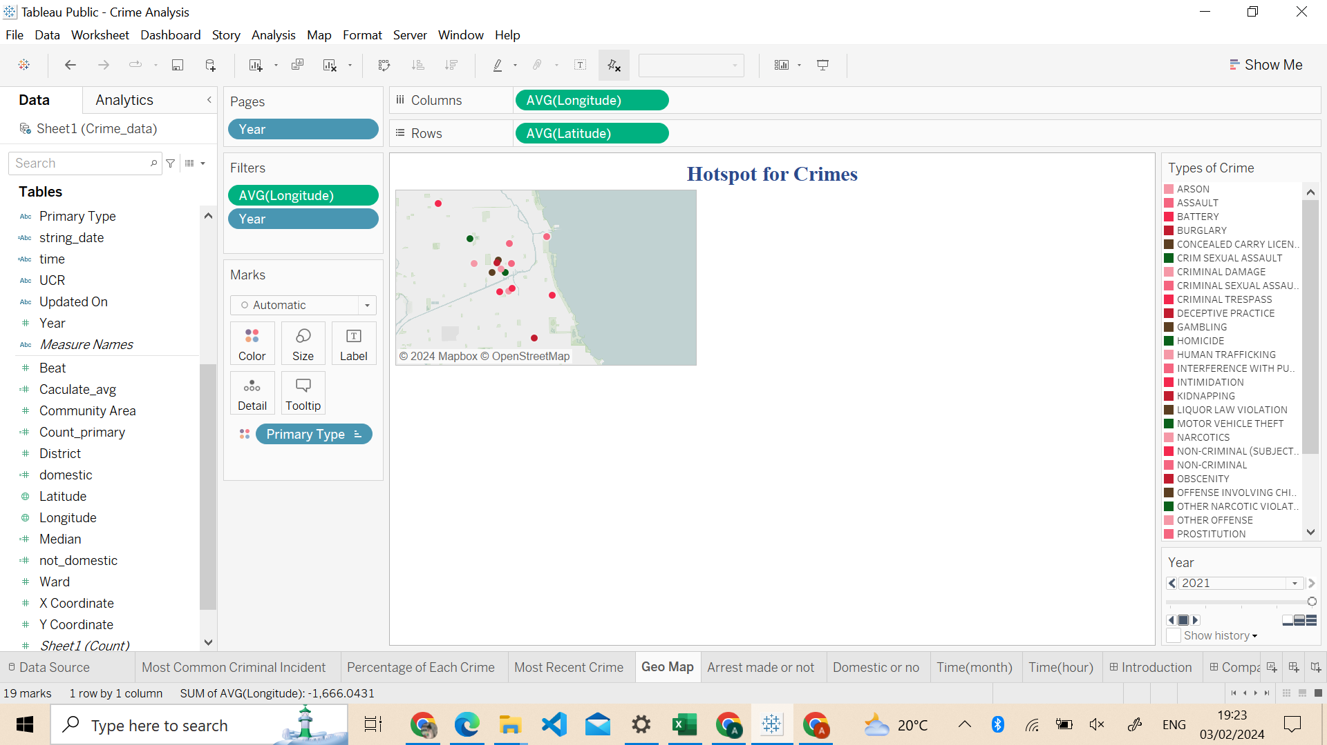

2.**Recent Crime details** - being updated about the recent updated crimes

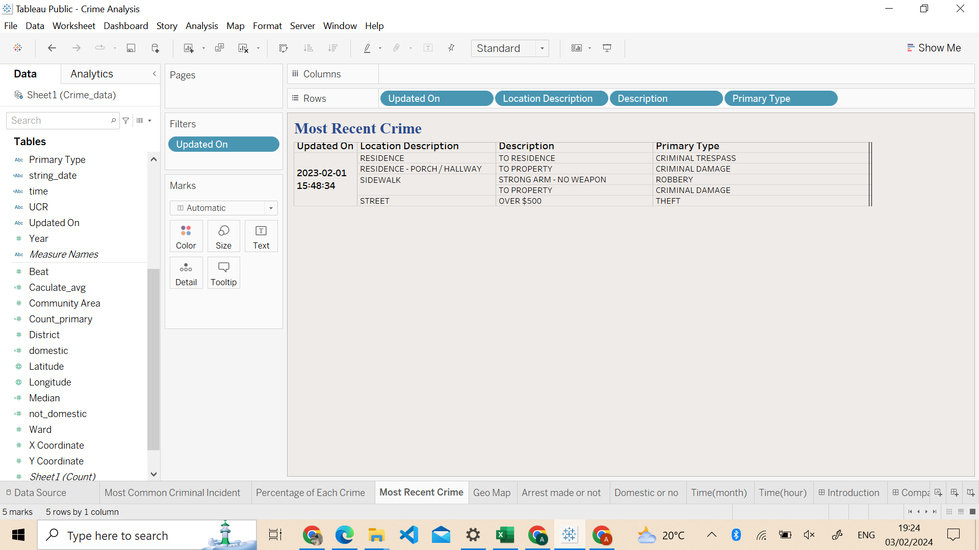

3. **Incident reported per year** - depict how many incidents were reported for each crime per year.

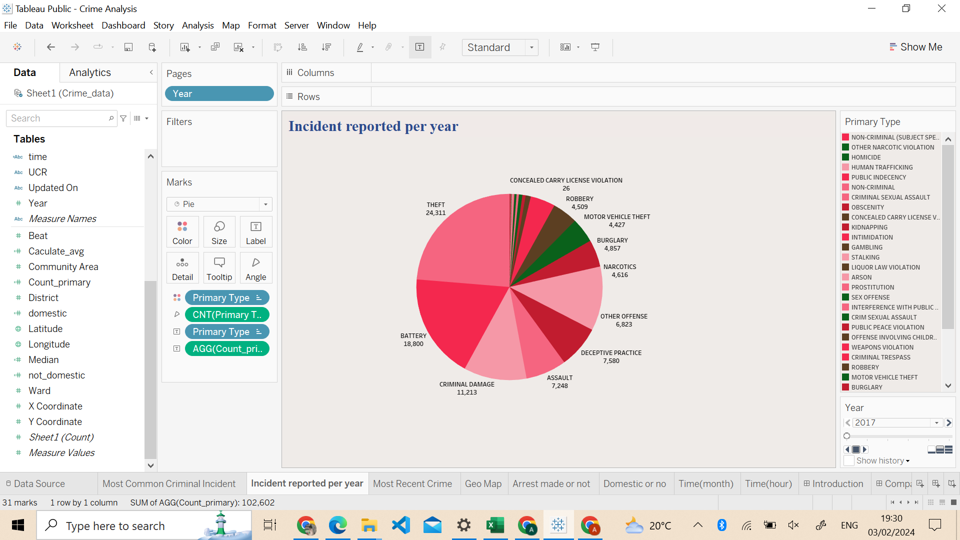

**Commonly reported crimes:** depict total incidents reported up till date and find the most common incident among them.

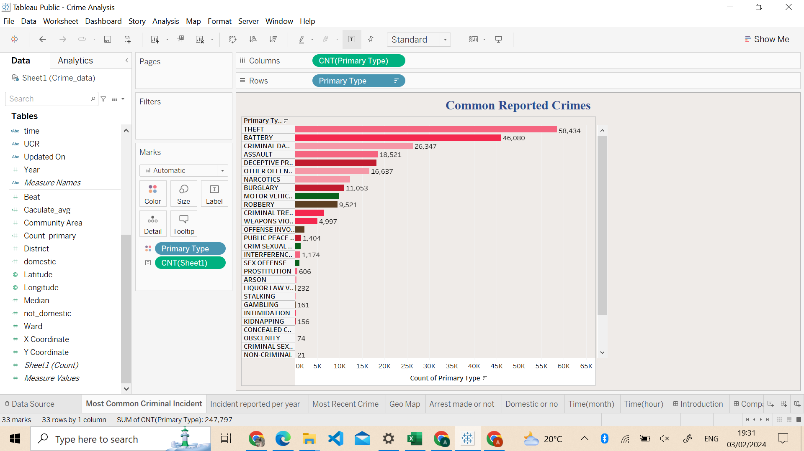

**Time Period Analysis:**

Analysing crime data over different time periods is essential for several reasons. It helps identify temporal patterns and trends in criminal activity, allowing law enforcement and communities to tailor their responses accordingly.

**1.Time(hour):** understanding the peak hour of the crime can increase police presence during those times to deter crime activity.

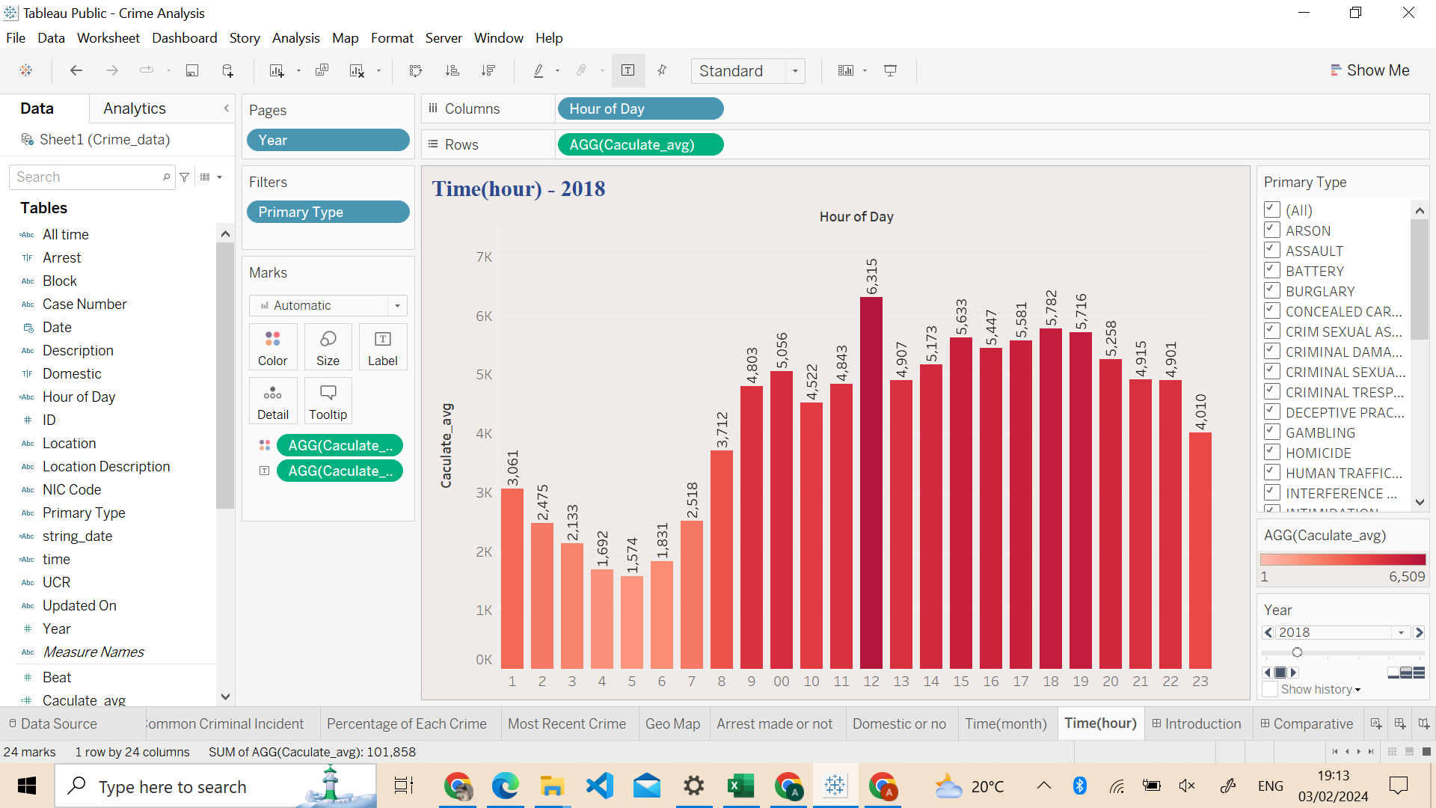

**2.Time(month):** By identifying historical patterns, law enforcement can anticipate when and where crimes are likely to occur, allowing for proactive measures to prevent or respond to incidents.

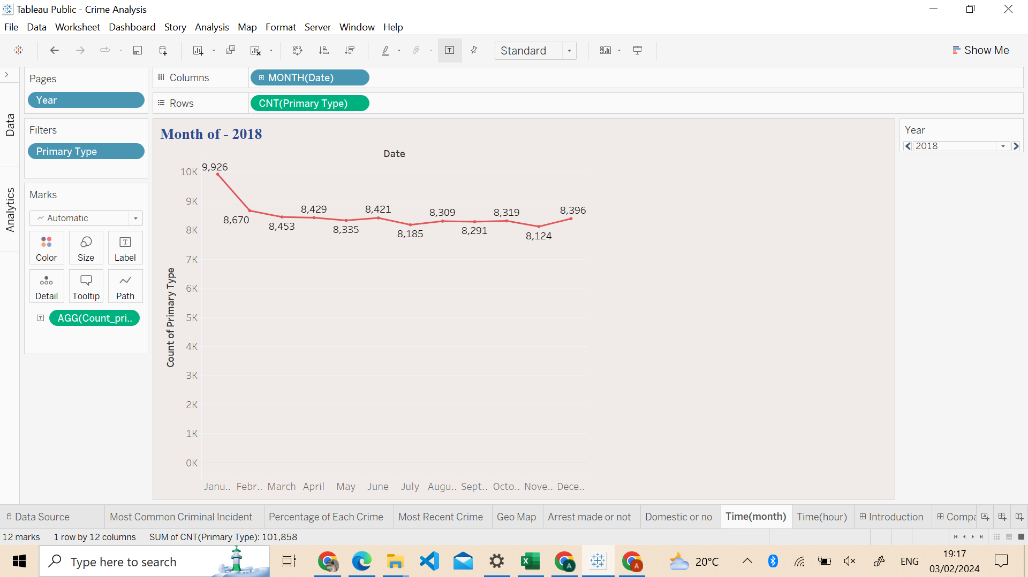

**Comparative Analysis:**

Comparative analysis is essential for gaining a broader perspective on crime data, enabling more informed decision-making, resource allocation, policy development, and provide preventative solutions.

**1.Domestic : True or False**

distinguishing between domestic and non-domestic crimes is essential for targeted resource allocation, risk assessment, investigation prioritisation, policy development, community support, and legal consequences

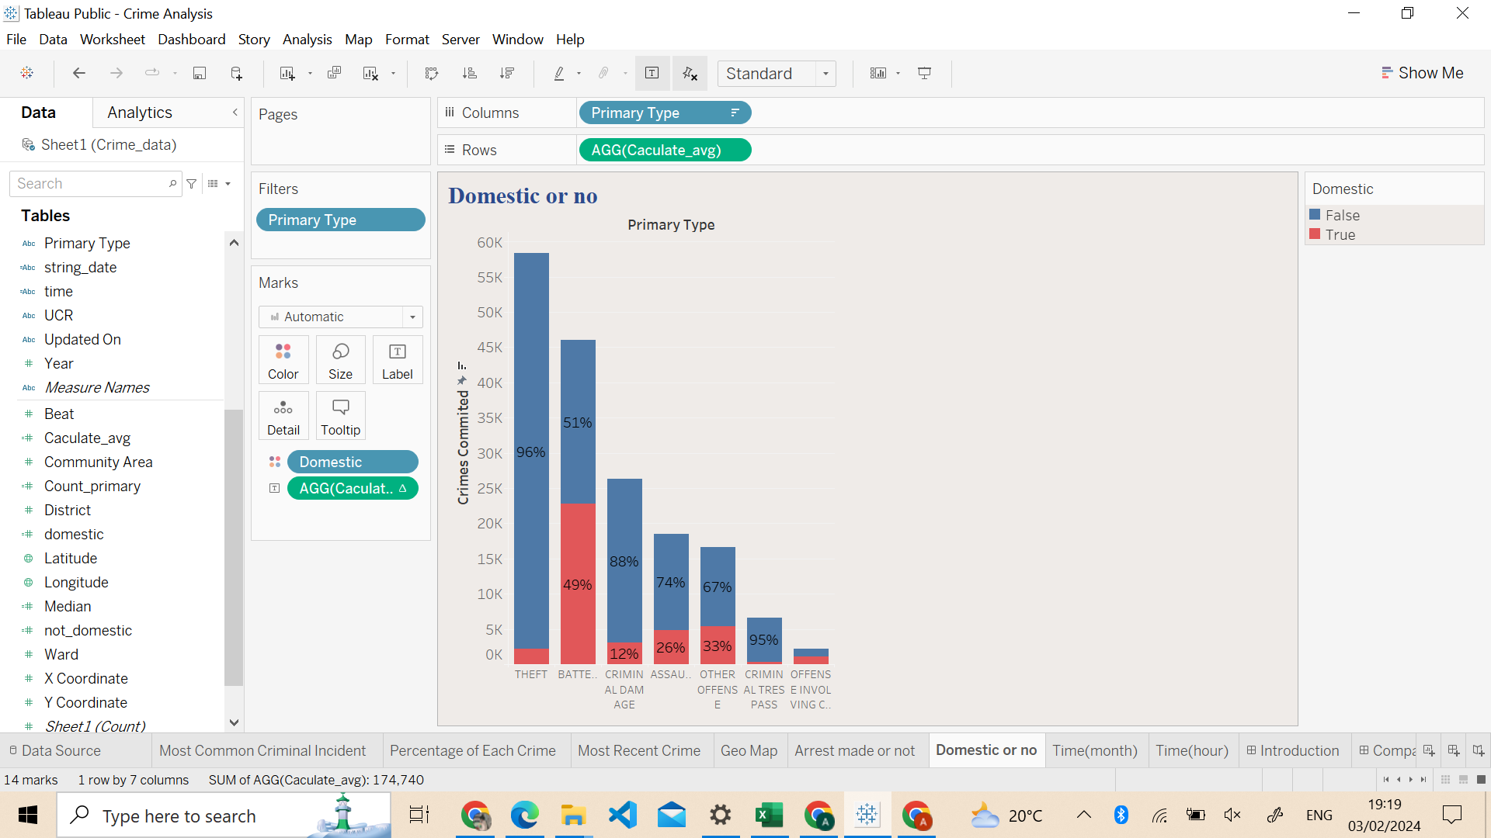

**2.Arrest: True or False**

Comparing whether certain crimes lead to arrests or not can have significant implications for law enforcement, criminal justice, and crime prevention efforts.

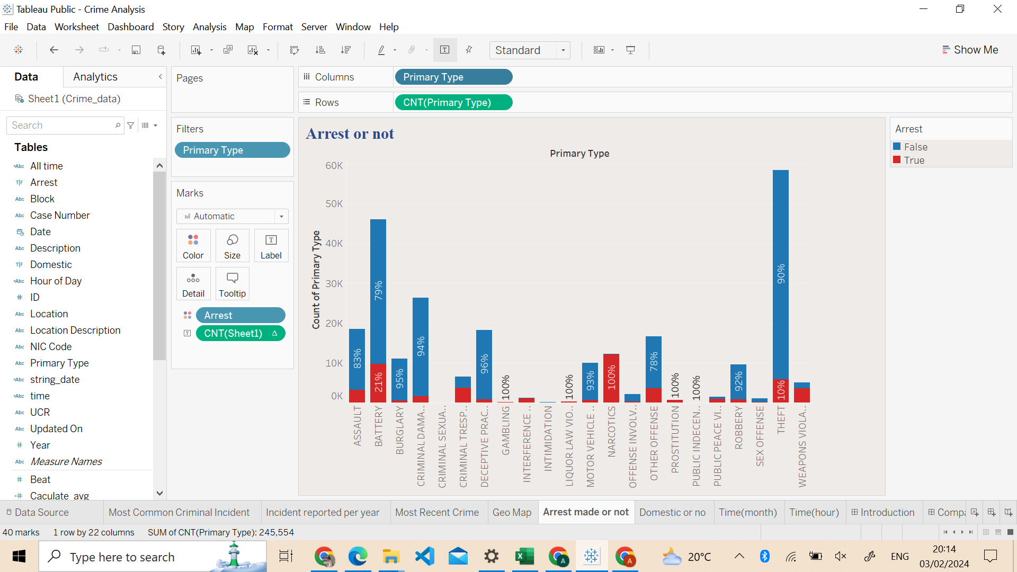

**Dashboard : Introduction Dashboard**

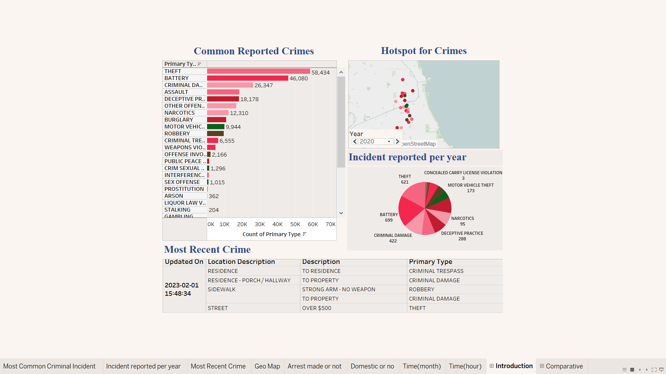

**Dashboard: Time period Analysis and preventative analysis**

